Pure Power Tactical Engine Programmer's Handbook

Purpose, Target and Prerequisites
The target of this article are people that have their first contact with PPTactical Engine and would like to use it and extend it. Also, the article should give several insights on how this engine is structured, possibly suggesting better solutions for people trying to design the architecture of a real-time strategy or related type of game.
Throughout the article, there will be presented class and sequence diagrams, so it is somehow necessary to have basic concepts of UML in order to read them. However, the text that accompany the diagrams should guide you just well. Also, previous knowledge of C++ is necessary.
The article will present two operations that are common when extending the engine: how to create a new unit type and how to add scripting to an existing unit type.
Since the game that was supposed to be powered by this engine was a realtime tactics game, the engine lacks all features that are more likely to be found in realtime strategy games, especially those related to building (e.g. Factories, Barracks). This article tries to address this issue by providing a step-by-step tutorial into implementing (some people like to call this hacking) a factory-like building.
In short, the factory building will be able to produce a infantry unit. Also, a rally point may be set, the units produced will be directed to move toward the rally point. A gui element will also be described, showing a progress indicator for the building process.
On a more in-depth note, it will be shown how to integrate the building into the existing class hierarchy, how to design and implement a subsystem for building and how to integrate this new subsystem with the factory, how to integrate into the loading process, how to make it sensitive to user commands and how to display back its informations. During this process, the architecture of the framework will be exposed in detail, allowing to further enhance and refine the existing code. Adding scripting to an existing unit type is common, as the existing scripting for units has a basic set of bindings that may not be enough for a level designer. We will add a script function for the units that will retrieve the hit points of a unit specified by in id. Thus, the scripting system and philosophy behind it will be presented, along with detailed implementation informations.

Technicalities
The engine is written in C++ and compiles with a variety of compilers on a variety of operating systems: Borland C++Builder 6, Borland C++BuilderX, Microsoft Visual C++ 6, Code::Blocks with Mingw, Xcode with g++ on Windows (98 to XP), Linux, Solaris, MacOS X. Part of the code – the editors for map and units – was written using Borland VCL and is not easily portable between compilers, thus, in order to modify the editors, one must have knowledge of VCL and generally, of Borland RAD concepts.
The framework comes with two modules: one, located in the src/Common folder is a game library and the other, located in src/Engine is the engine framework.
The Common, as stated above is a game library and offers a lot of features. There is abstractization of the hardware (or devices or drivers), like support for DirectX and SDL in terms of graphics and sound, a font abstraction (implemented for the DirectX as GDI fonts and for SDL as SDL_font library), input abstraction (for mouse and keyboard), file input&output with support for multiple IO schemes (direct or zip access). Common also stars a full-featured GUI is present, written in-house and designed in the veins of the Borland VCL, a script language called CSL that is the work of Peter Koch (http://sourceforge.net/projects/csl), loading of various image and sound formats, platform detection, logging and more.
The Engine framework has two modules. One is composed of the unit hierarchy, unit control and mission control, while the other is an extension of the aforementioned GUI that implements the whole look-and-feel of a game.
Here's a small engine dictionary, presenting the terms used through-out the article and the engine.
Units and Objects. Models a real world (or game world) entity. An unit is something that the user has a certain amount of control over it (like a soldier) while an object is an entity that the user/player does not have any control (like a tree, an explosion and so on). This was the original design philosophy, but in the source code things are a bit messed. The unit also acts as a dispatcher of actions by distributing them to the appropriate subsystems when such an action comes from the mission or from other source.
Statics. Another name for a building.
Mission.A god-class that concentrates the whole game logic (updates, paints, unit management, loading and saving). It is implemtented in the terms of the singleton design pattern.
Map. Handles all map geometry like layers, visibility (fog-of-war) and unit placement.
Battlegroup. A logic manager of units. There are two default battlegroups, the player battlegroup (in which the player units are gathered) and landscape, where all the neutral objects and units may be located. Each battlegroup may have a script attached, thus giving the possibility to mix individual behaviour with a group behaviour. This script may be also attached to the player battlegroup, thus defining a so-called agent, helping the player in certain moments.
Politics. A battlegroup may be neutral, friendly and hostile toward another battlegroup, thus the name. The politics may be edited with the map editor or modified at run-time with direct calls or through scripting.
Doctrine. Also known as script. Many of the engine framework components have the possibility to be controlled by a specific script: the mission (controlled via MissionControl), battlegroups, individual units.
Subsystem (or subsys). An unit or an object may be composed of subsystem, such as a real-world tank being composed of a body and a turret. In the engine, a tank, for example, is composed of a body, a sensor, a visual, a propulsion and a turret subsystems. Each subsystem may execute an action and while the unit acts as a mediator (as in the design patterns) between the subsystem, this allows in a smoother way that a unit may perform several tasks in the same time. This design also allows reusal of code, because many of the subsystems are common to different unit types. The subsystems are a hierarchy parallel to the unit hierarchy, allowing the units to delegate the messages to the component subsystems.
Actions. What a subsystem does at a certain moment of time, for example attack, move, build. There are several types of actions, which involve one or more of the following: a starting point, an ending point or a target object. Only one action is active per subsystem. The actions may be grouped in a queue.
Capabilities. A system that allows to query what a unit can do. For example, one may query if a unit can carry infantry units, or carry vehicle units or if it can load or unload units. The capabilities are not static/hardcoded, they may change during the life a unit.

Our Place in the World

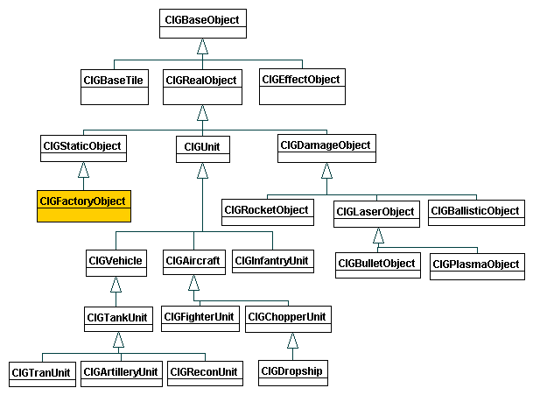Illustration 1 The Engine Units and Objects Classes

CIGBaseObject is the root of the hierarchy, providing the common interface for all the objects in the hierarchy: actions dispatchers (SetAction, AddAction), Paint, Update, Serialize/DeSerialize, notifications in the maps (layer map, logic map), capabilities query (Can).
CIGRealObject is the hub where all the objects and units that have physical/palpable substance will inherit. A real object (or unit) will thus have hit points, mass, resistances to various elements (plasma, explosions, bullets), unique id and may belong to a battlegroup. A real object can be selected on the screen.
CIGUnit is the hub for all units – entities that react to the user commands. This class defines the script interface that is common to all units, that each unit type (aircraft, tanks) will use to extend.
CIGVehicle is the base class for all ground vehicles: tanks, recon, artillery and CIGAircraft is the base class for all aircrafts: fighters, choppers, dropships. This part of the hierarchy starts to be game specific.
CIGStaticObject is the base class for all buildings. In previous releases and in the original design, statics (buildings) were supposed to have only a passive role (could not execute orders). This changed, so a refactoring is needed in order to move this class as a child of CIGUnit.
The place of our new class, CIGFactoryObject, can be easily observed in the hierarchy.

Creating the Factory
Let's start with the end, and I'm pretty sure I'll have the agreement of all good teachers in doing such thing. The Figure 2 shows what is our visual goal in terms of look and a suggested bit of feel.
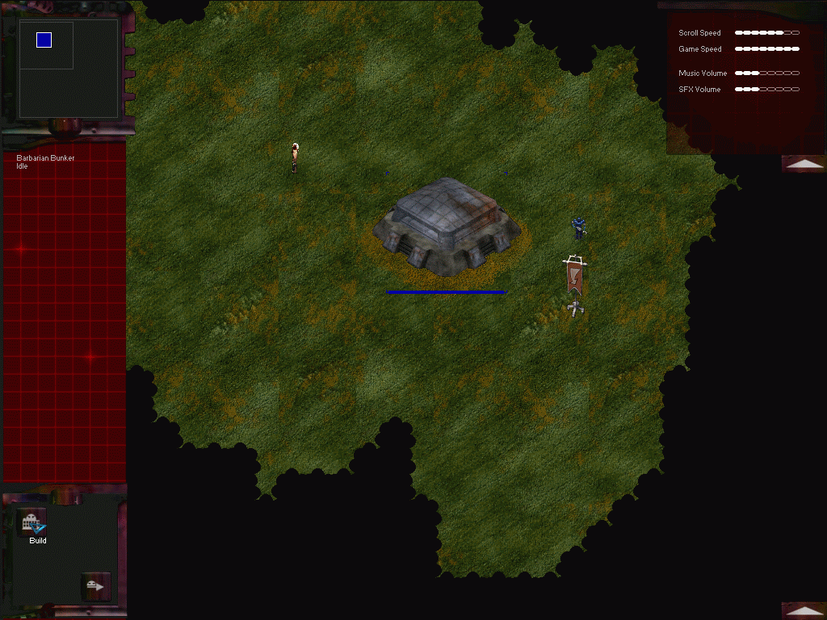Illustration 2 The End Result
Please observe in Figure 1 the building with the rally point, a blue soldier that was just spawned (“trained”) walking toward the rally point, the actions the building is able to perform (buttons in the left-bottom corner) and the building info area in the left-middle part of the screen.
With this fresh impression of image in mind, let's get down to the nitty-gritty part, the design and programming.
First, we need to find a suitable place in the hierarchy for a class that is a building and can build things. The most obvious place would be to make it inherit from the CIGStaticObject and exactly this is what we'll do. So let's place the class into PPIG_ObjFactory.h/cpp and write it down, as seen in Listing 1.
Each unit class implements a simple RTTI mechanism through ClassName() and IsDerivedFrom() methods, allowing the detection of a class of an object and the possibility to check the ancestor class of an object. The IGCN_FACTORYOBJECT is a constant that is defined PPIG_EngineDef.h. The RTTI mechanism is mandatory if you plan to serialize or deserialize the class through the mission (CIGMission) class.
Usually, every new unit class needs to implement custom Paint() and Update() methods, to extend the behaviour of their ancestor. While painting is somehow standardized, update requires a special attention, because it dispatches the update to the subsystems objects, separating them into high-priority and low-priority. The same message dispatching mechanism also applies for the AddAction() and SetAction() methods, which will forward the action to the subsystems depending on the action type, like in the Listing 2:
Of course, we only have one active subsystem, the builder subsystem, because the setting of the rally point is done within the boundaries of the unit class.
As stated before, the unit class is a mediator for its subsystems, allowing decoupling and reusing of the subsystem classes, while for outside objects (like other unit classes or gui classes) acts as a facade (see design patterns). Other classes should not care about the internal structure of our unit class.
Now, we need to make the class only receive two actions via the user interface (actually they will come via the mission): build a unit and setting of the rally point. A unit object has a so-called action mask, which specifies what kind of actions is able to perform. The user interface will check for the action mask of the selected unit and will enable only the required buttons. Setting the action mask for the factory comes as a one-liner:
SetActionMask((1<<MA_BUILD) | (1<<MA_RALLY_POINT));
where the MA acronym stands for mission action – it is a message code send from GUI to the mission. There are many other mission actions, all defined in PPIG_EngineDef.h) and, for example, the infantry unit has a bit more complex action mask pattern:
SetActionMask((1<<MA_STOP) | (1<<MA_MOVE)|(1<<MA_ATTACK)|(1<<MA_PATROL)|(1<<MA_GUARD)|(1<<MA_HOLD)|(1<<MA_CAPTURE)|(1<<MA_SUPPRESS_FIRE)|(1<<MA_TAKE_COVER));
Now, let's prepare the factory for loading from file. Since a full implementation would require the modification of the map editor in order to make it recognize (aka serialize, deserialize and place) the factory class and we only want to quickly prototype the factory, we'll adopt a small hack: all statics loaded from the map will be transformed to CIGFactoryObject instead of the default CIGStaticObject. Thus, we must open the PPIG_ObjectCreator.cpp and scan the CIGObjectCreator – we find in no time that it is a factory class, that creates objects based on an id:
CIGBaseObject* CIGObjectCreator::CreateObjectFromId(int _id)
In the full implementation, we would add another case in this method:
case OBJT_FACTORY: return new CIGFactoryObject();
but right now we'll only tunnel the static object to a factory object:
case OBJT_STATIC: return new CIGFactoryObject();
Let's now hook-up with the mission class (CIGMission), in order for the factory to receive the orders from the player. To link the build action, we must first notice that this action behaves as: with the factory selected, we press the “build” button and the unit production begins. This is a one time action, just like aircraft takeoff or infantry take cover, so we'll add a new case in CIGMission::SetAction() method, just like in Listing 3. The sequnce diagram in Figure 3 shows in the detail the flow (note that OA_* stands for “object action”, that is a message code that is send to a unit (from mission, from mission scripting or from other units) and screen stands for CPIMainScreen, which is the holder for all GUI callbacks).
For the rally point setting, we should observe how the actions flows: press the “rally point” button and click on the map - this action closely resembles the move action. We'll add code to the CIGMission::ComputeCurrentAction() and to the CIGMission::SetBeginPoint() and don't forget to check Figure 4 for the sequence diagram (note that GUI is a generic name for either CPIBattleControl or CPIRadarControl, two controls that treat game mouse actions, in this case mouse left button down action).

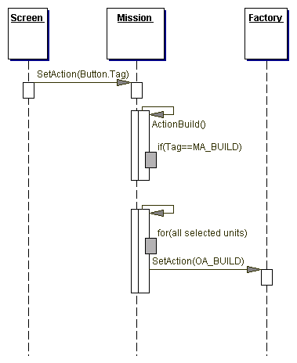Illustration 3 The Sequence Diagram for the Build Action

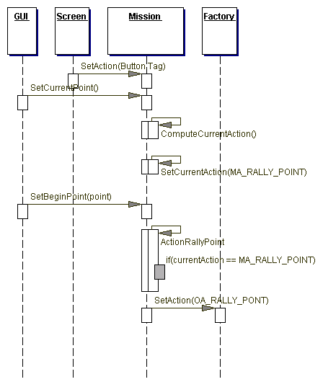
A new subsystem is needed for the factory so that design to be consistent. We'll create a builder subsystem class in the PPIG_SubSysBuilder.h/cpp, deriving it from CIGSubSysBase:
class CIGSubSysBuilder : public CIGSubSysBase
This new class, along with all the other subsystem implementations, has two important aspects. One is CIGSubSysBuilder::GetActionInstance() method, which will return an action class instance (CIGSubSysActionBuild). The other is CIGSubSysBuilder::OnActionBuild() which will actually handle (CIGSubSysActionBuild::Handle()) the whole factory production routine, creating the produced infantry unit, place it on the map and order it to head to the rally point. The code is quite complex to list here, so check the Figure 5 for the flow diagram.
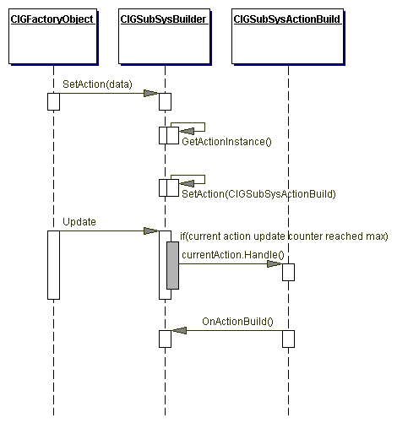Illustration 4Action Updating Sequence
One thing remains: adding visual feedback of the building actions in the GUI. We only want to design the GUI to show the building name and a progress indicator, so let's create the CPIFactoryInfo class in PPIG_CFactoryInfo.h as in Listing 4.
CPIFactoryInfo will be responsible for extracting data from the associated CIGFactoryObject and painting it to its area. CPIFactoryInfo will be made available through another factory-like class, CPIUnitInfo. We'll make sure to plug-in the creation of a CPIFactoryInfo control in CPIUnitInfo::ComputeControlType() depending on what is selected on the screen. Thus CPIUnitInfo will know what unit specific control to paint:
void CPIUnitInfo::Paint() {
CPIWinControl* lControl = ComputeControlType();
if (lControl) lControl->Paint();
}
In the end, a bit of statistics: 4 classes were created and 4 other files received minor changes or additions (up to 10 lines of code), for no more than 300 lines of code.

Scripting
Let's remember the goal for this part of the article: we will add a script function for CIGUnit class that will retrive the hit points of a unit specified by an id. Adding this for CIGUnit will make the function available for all vehicles, aircrafts and infantry units.
But before jumping into the fray, we should prepare first with knowledge on how the scripting system works.
The scripting language is called CSL (C Scripting Language), was written by Peter Koch and is licensed under GPL. Its syntax closely resembles the C language, the variables and constants have no types and it lacks structures and classes. From the programming point of view, the compiling and running of scripts is performed through the ZCsl class and each unit class that wants to offer scripting capabilities must have an instance of ZCsl class.
Working with ZCsl class is straight-forward: first, create an instance of the class:
mCompiler = new Zcsl();
Then init and add the libraries, if you have any:
ZLibrary* lib= new ZMathLib(mCompiler, "A Library");
lib->InitLibrary();
mCompiler->loadLibrary(lib);
Then, init the handlers:
mHandleStuff.set(this, &CIGUnit:: mcStuff);
Then init the scripting interface, by associating the handlers (callbacks, pointer to members) to a scripting function definition:
mCompiler->addFunc(ModuleName, MemberDefinition, mHandleStuff);
Load the script, in order to compile it and have it ready to run. The ScriptString is a istringstream that contains the script:
mCompiler->loadScript(ModuleName, ScriptString);
Later on, when we need to execute the script, we'll actually call a function within the script:
mCompiler->call(ModuleName, "afunction");
Now let's personalize this algorithm for our case.
First, we'll define a callback (or handler) in CIGUnit class:
ZCsl_callback_t mHandleUnitHP;
And also we'll define in the CIGUnit class the method that will be called back and will actually return the hit points:
ZString mcUnitHP(ZCsl* csl);
Add the initialization of the handler in CIGUnit::InitHandlers():
mHandleUnitHP.set(this, &CIGUnit:: mcUnitHP);
Ask the mCompiler to associate the function definition to the handler in CIGUnit::InitScriptingInterface():
addModuleFunc("UnitHP(const id)", mHandleUnitHP);
Please note that in a CSL script that will be associated to a unit, we'll use this new function as, for example:
var id = 128;
var unitHP = UnitHP(id);
The last step that remains is to implement CIGUnit::mcUnitHP as in Listing 5. Please note that the parameter of UnitHP, id, comes in CIGUnit::mcUnitHP as ZString and needs to be converted to int. The result returned by our method is also ZString.

Hell's Kitchen
The code written for this article is based on a work-in-progress version – basically a pre-release of 0.9.7. All modifications were marked using the comment:
// TEST CODE FOR SDJ
so a quick Find in Files should work as charm.
There are project setups for C++Builder 6 (located in dev\bcb\engine_sdl), C++Builder X (located in dev\builderx\engine_sdl) and Code::Blocks with mingw (located in dev\codeblocks\engine_sdl) especially for this article. Unfortunately, the mingw-generated executable is not stable yet, but it should give at least a head-start for those using this free compiler suite..
The Microsoft Visual C++ 6 project may be enhanced with three clicks, basically by adding the PPIG_ObjFactory.cpp, PPIG_SubSysBuilder.cpp and PPIG_CFactoryInfo.cpp to the project.

The Next Steps
Since this article was just a quick crash-course on the engine, many details remain to the reader to tackle. Details like adding multiple building options, like a factory able to produce antitank infantry, assault infantry and so on, improved factory info GUI control, extending the statics editor and the map editor to support factories, a tech tree, eventually a generic and script controlled one would be very easy to integrate into the existing code.

Listings
<<LISTING lang=C++>>
class CIGFactoryObject : public CIGStaticObject
{
public:
CIGFactoryObject();
virtual ~CIGFactoryObject();

virtual CPString ClassName () { return IGCN_FACTORYOBJECT; }
virtual bool IsDerivedFrom (CPString className);
virtual void Update ();
virtual void Paint(CPPoint ptViewPort, CPPoint ptWindow, int Width, int Height, int zoomLevel = 1);

public: // action
virtual void AddAction(TIGSubSysActionData actionData);
virtual void AddAction (CIGSubSysAction *Action);
virtual void AddActionWithPriority (CIGSubSysAction *Action);
virtual void SetAction (TIGSubSysActionData actionData);

public: // get-set
CPPoint GetRallyPoint() { return mRallyPoint; }
bool IsBuilding();
int GetProgress();

public:
virtual void DeSerialize(PP::Stream& _a);

private:
CPPoint mRallyPoint;
CPGISprite* mRallyFlagSprite;
CIGSubSysBuilder* mBuilder;
};
Listing 1. The CIGFactoryObject class.
<</LISTING>>
<<LISTING lang=C++>>
void CIGFactoryObject::SetAction (TIGSubSysActionData actionData)
{
switch (actionData.mType)
{
case OA_BUILD:
mBuilder->SetAction(actionData);
break;

case OA_RALLY_POINT:
mRallyPoint = actionData.mTargetPoint;
break;
}
}
Listing 2. Dispatching the actions to the subsystems.
<</LISTING>>
<<LISTING lang=C++>>
void CIGMission::SetAction(int value)
{
switch(value)
{
case MA_BUILD:
ActionBuild();
break;
}
}
Listing 3. Hook-up the build action.
<</LISTING>>
<<LISTING lang=C++>>
class CPIFactoryInfo : public CPIWinControl
{
public: //c-d
CPIFactoryInfo(CPIWinControl *Parent = NULL);
virtual ~CPIFactoryInfo();
public:
virtual void Update();
public: // get-set
void SetFactory(CIGFactoryObject* _factory);

private:
CPILabel* mLabelProgress, *mLabelName;
CIGFactoryObject* mFactory;
};
Listing 4. The factory GUI control
<</LISTING>>
<<LISTING lang=C++>>
ZString CIGUnit::mcUnitHP(ZCsl* csl) {
int lId = csl->get("id").asInt();
CIGBaseObject* lObj = GetMissionInstance()->GetObjectById(lId);
// check if object exists
if (!lObj) {
return -1;
}
if (!lObj->IsDerivedFrom(IGCN_REALOBJECT)){
return -1;
}
// check if in visual range!
CPPoint coord = GetLogicCoord();
if (!InVisualRange(lObj->GetClosestPointTo(coord).x, lObj->GetClosestPointTo(coord).y)) {
return -1;
}
return (dynamic_cast<CIGRealObject*>(lObj))->GetCurrentHP();
}
Listing 5. The implementation of CIGUnit::mcUnitHP
<</LISTING>>

